Experiment 6: Logistic Regression
Francis Reuben R
Department of Computer Science and Engineering, RV University
Data Science Laboratory, Semester 3, Section G | USN: 1RUA25CSE0168 | 16 October 2026

Objective
Predict a yes-or-no outcome with logistic regression. The first model predicts whether a person buys life insurance from age. The second classifies gender from height and weight, fit by gradient descent. The third predicts whether an employee leaves, using satisfaction, monthly hours, a recent promotion, and salary.

Description
insurance_data.csv has 27 rows and two columns, age and bought_insurance. Fourteen people bought a policy and thirteen did not. Ages run from 18 to 62. The split is 80/20 with random_state 4, which gives 21 training rows and 6 test rows. sklearn.linear_model.LogisticRegression fits the line inside the sigmoid. A probability of 0.5 or more is read as a purchase. The same coefficients, rounded to 0.21 and -8.69, are checked by hand at ages 32 and 43.
weight-height.csv has 10,000 rows, 5,000 male and 5,000 female, with Height in inches and Weight in pounds. Gender is coded Male = 1 and Female = 0. Height and weight are z-scored on the full table, and a column of ones carries the intercept. All 10,000 rows are kept, including three heights above 90 inches. Gradient descent starts at theta = 0 and updates theta = theta - 0.1 * (1/m) * X.T * (prediction - y) for 1,000 steps. The loss is binary cross-entropy. The confusion matrix and the classification report are computed on these same 10,000 rows, so the 0.91 accuracy is the fit on the training table, not a held-out test. The descent is then repeated for 300 steps at learning rates 0.001, 0.01, 0.1, 1, and 5.
HR_comma_sep.csv has 14,999 employees and 10 columns. The target left is 1 for 3,571 people (23.8 percent) and 0 for 11,428. The notebook loads the file from the public codebasics mirror of the HR analytics table. A copy is stored beside the notebook. Group means compare people who left with people who stayed. Count charts show salary and department. The model keeps satisfaction_level, average_montly_hours (the file spells it that way), promotion_last_5years, and salary. Salary is nominal, so low and medium are indicators and high is the reference (drop_first removes the first level in alphabetical order). The split is 70/30 with random_state 42: 10,499 train and 4,500 test. LogisticRegression is fit with max_iter 1,000.

Flowchart
Figure 1 is the pipeline in Ex.No.6.ipynb. The charts from that notebook are Figures 2 to 7.
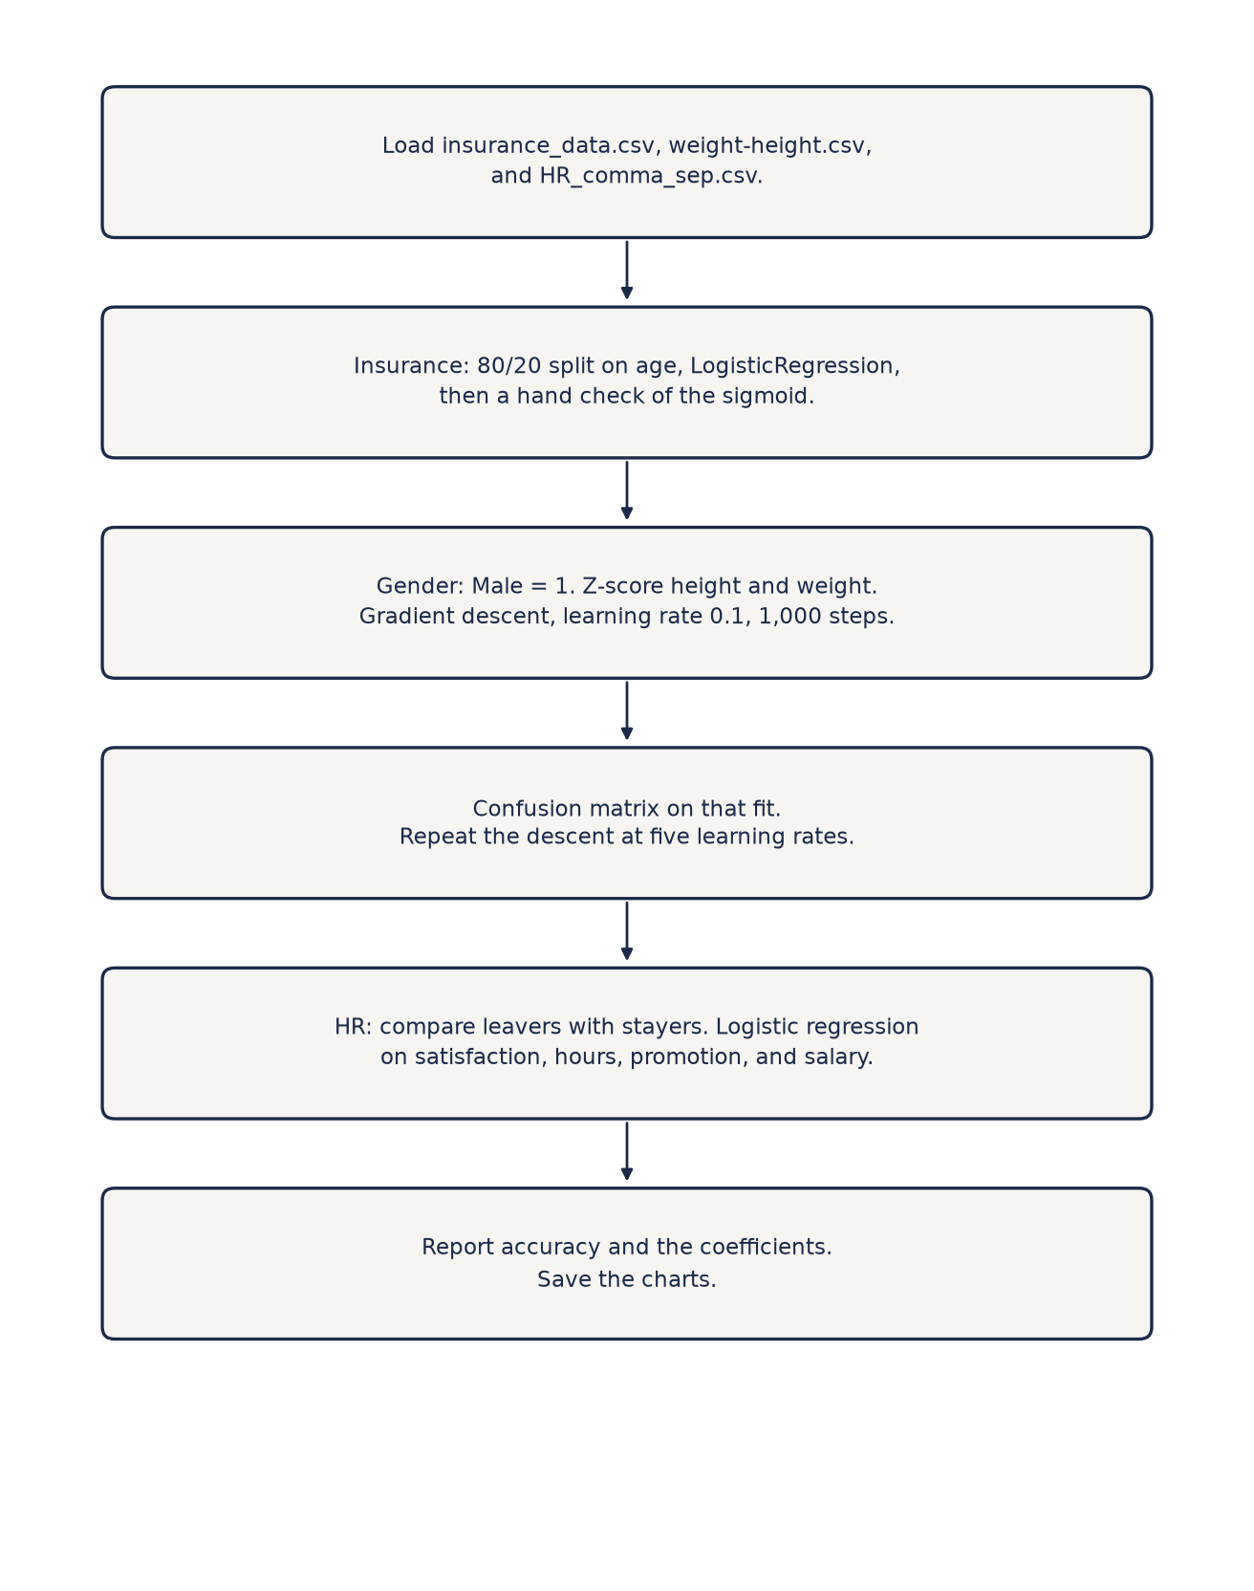
Figure 1. Pipeline for the insurance model, the gender gradient descent, and the HR retention model.

Algorithm
- Start. Import pandas, numpy, matplotlib, seaborn, and scikit-learn.
- Load insurance_data.csv. Scatter age against bought_insurance.
- Split age 80/20 with random_state 4. Fit LogisticRegression. Print the coefficient, the intercept, the test labels, the probabilities, and the accuracy.
- Define the sigmoid. Evaluate 0.21 * age - 8.69 at ages 32 and 43.
- Load weight-height.csv. Code Male as 1 and Female as 0. Z-score height and weight and add a column of ones.
- Run gradient descent for 1,000 steps at learning rate 0.1. Plot the loss. Predict male when the probability is at least 0.5.
- Print the confusion matrix and the classification report. Repeat the descent for 300 steps at five learning rates and plot the five curves.
- Load HR_comma_sep.csv. Print the shape, the head, and the mean of each numeric column for left = 0 and left = 1.
- Plot salary and department against left. Fit LogisticRegression on satisfaction, monthly hours, promotion, and salary indicators. Print test accuracy.
- End.

Life insurance
The fitted logit is z = 0.2100 * age - 8.6878. The probability crosses 0.5 at age 41.4, so the model predicts a purchase from about 42 years upward. On the six test rows the accuracy is 0.50: three calls are right and three are wrong. The misses are a 25-year-old who bought, a 40-year-old who bought (probability 0.428, just under the cut), and a 52-year-old who did not. With six test rows, one miss moves the accuracy by 0.17.

Measure | Result
Rows | 27 (14 bought, 13 did not)
Train / test | 21 / 6, random_state 4
Coefficient on age | 0.2100
Intercept | -8.6878
Age where P = 0.5 | 41.4 years
Test accuracy | 0.50 (3 of 6)
The hand check uses the rounded line z = 0.21 * age - 8.69. At age 32 the probability is 12.24 percent, so the prediction is no purchase. At age 43 it is 58.42 percent, so the prediction is a purchase. The fitted model at those two ages is 12.25 percent and 58.44 percent.

Age | Bought | Predicted | P(buy)
50 | 1 | 1 | 0.859
25 | 1 | 0 | 0.031
40 | 1 | 0 | 0.428
22 | 0 | 0 | 0.017
52 | 0 | 1 | 0.903
18 | 0 | 0 | 0.007
Figure 2 is the full table of 27 people. Purchases cluster at older ages, with a few exceptions, which is why a line on age cannot score well on a six-row test.
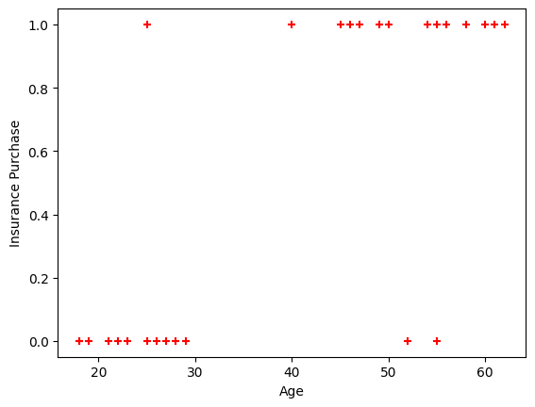
Figure 2. Age against insurance purchase for all 27 rows.

Gender from height and weight
After 1,000 steps the intercept is 0.0310, the height coefficient is 0.1468, and the weight coefficient is 3.4820. Weight carries the separation. The loss starts at 0.6931, which is ln 2, because the first prediction is 0.5 for every row. It is 0.3472 at step 50 and 0.2326 at step 1,000.

Term | Value
Intercept | 0.0310
Height (z-score) | 0.1468
Weight (z-score) | 3.4820
Loss at the start | 0.6931
Loss at step 50 | 0.3472
Loss at step 1,000 | 0.2326
Accuracy on the 10,000 rows | 0.91 (9,051 of 10,000)
Figure 3 is that loss curve. Figure 4 is the confusion matrix on the same rows. Of 5,000 women, 4,528 are called female and 472 are called male. Of 5,000 men, 4,523 are called male and 477 are called female. The notebook prints precision and recall of 0.91 for both classes.
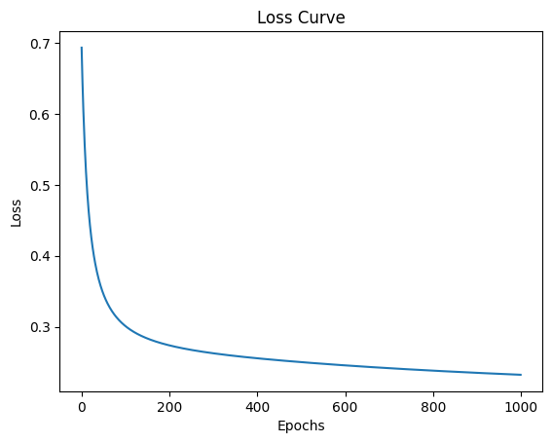
Figure 3. Binary cross-entropy over 1,000 steps at learning rate 0.1.
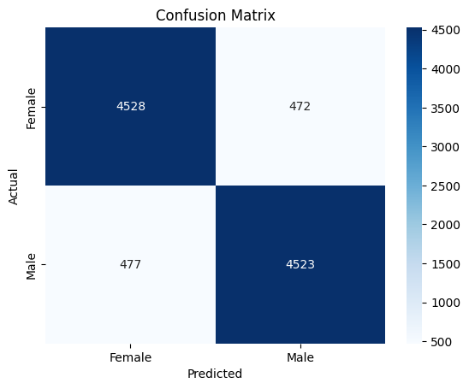
Figure 4. Confusion matrix for gender, scored on the 10,000 rows used to fit the model.

Learning rate
Figure 5 runs the same descent for 300 steps at five learning rates. Every curve starts at 0.6931 and is still falling at step 300. A larger step reaches a lower loss in this window. The rate 5.0 does not diverge on this z-scored table. The rate 0.001 has barely left the start.

Learning rate | Loss after 300 steps
0.001 | 0.6255
0.01 | 0.3944
0.1 | 0.2629
1 | 0.2188
5 | 0.2143

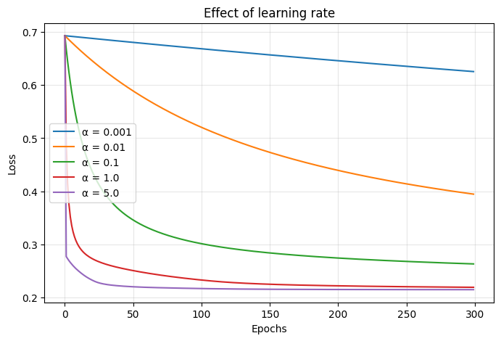
Figure 5. Loss over 300 steps at five learning rates.

Employee retention
People who left are less satisfied (0.440 against 0.667), work slightly longer hours (207 against 199 in a month), have spent longer at the company (3.88 years against 3.38), and almost never received a promotion in the last five years (0.5 percent against 2.6 percent). Last evaluation and the number of projects barely differ. The model uses satisfaction, hours, promotion, and salary, which are the columns the notebook kept after this comparison.

Measure | Stayed (left = 0) | Left (left = 1)
Employees | 11,428 | 3,571
Satisfaction | 0.667 | 0.440
Last evaluation | 0.715 | 0.718
Number of projects | 3.79 | 3.86
Average monthly hours | 199.1 | 207.4
Years at the company | 3.38 | 3.88
Work accident (share) | 0.175 | 0.047
Promotion in 5 years (share) | 0.026 | 0.005
Low salary has the highest leave rate, 29.7 percent. High salary has the lowest, 6.6 percent. Figure 6 counts people rather than rates, and the low and medium bars are large because those bands employ most of the company. The rate column is the comparison that does not depend on band size.

Salary | Stayed | Left | Leave rate
High | 1,155 | 82 | 6.6%
Medium | 5,129 | 1,317 | 20.4%
Low | 5,144 | 2,172 | 29.7%

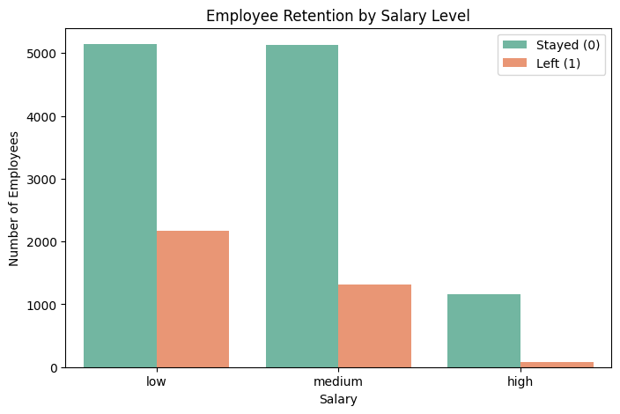
Figure 6. Headcount by salary band, split by whether the employee left.
Department leave rates sit in a narrow band except at the two ends. HR is highest at 29.1 percent and management is lowest at 14.4 percent. Sales looks large in Figure 7 because it is the biggest department (4,140 people), not because its leave rate is unusual. The sales rate is 24.5 percent, close to the company rate of 23.8 percent. Department is not a predictor in the fitted model.

Department | Employees | Left | Leave rate
hr | 739 | 215 | 29.1%
accounting | 767 | 204 | 26.6%
technical | 2,720 | 697 | 25.6%
support | 2,229 | 555 | 24.9%
sales | 4,140 | 1,014 | 24.5%
marketing | 858 | 203 | 23.7%
IT | 1,227 | 273 | 22.2%
product_mng | 902 | 198 | 22.0%
RandD | 787 | 121 | 15.4%
management | 630 | 91 | 14.4%

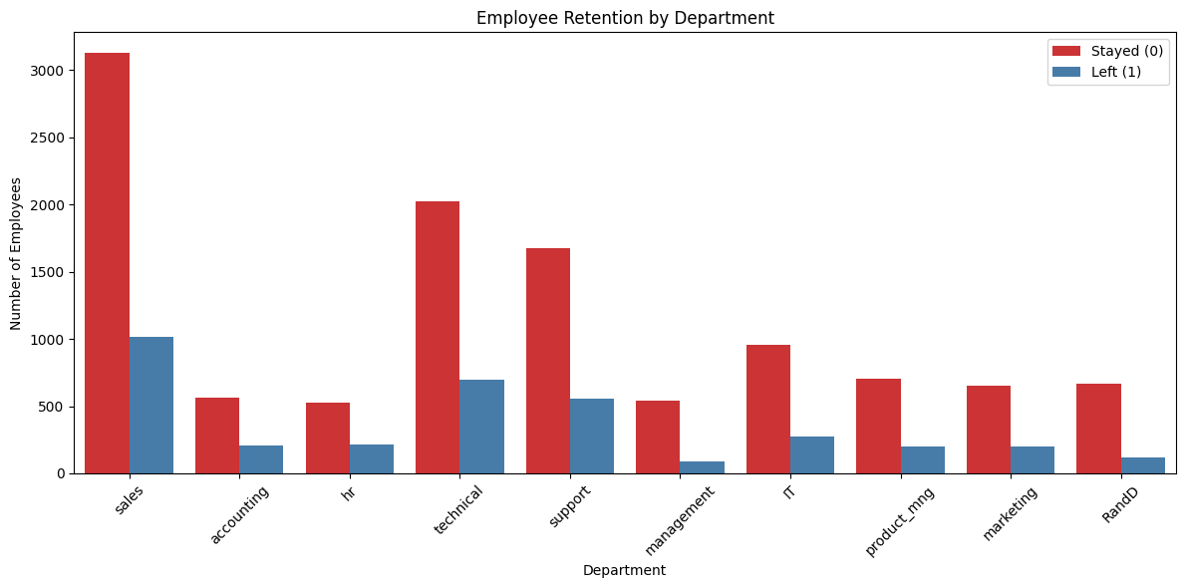
Figure 7. Headcount by department, split by whether the employee left.

Retention model
On the 4,500 test rows the accuracy is 76.76 percent. Predicting that nobody leaves would score 3,428 of 4,500, which is 76.18 percent, so the accuracy is only a small step past that baseline. Of the 1,072 leavers in the test set, the model finds 258 (recall 0.241) and misses 814. It falsely flags 232 people who stayed. Precision on the leave class is 0.527. Precision on the stay class is 0.797 and recall on that class is 0.932. The model is accurate mostly because most people stay.
The coefficients are on the logit. A higher satisfaction level lowers the log-odds of leaving by 3.818 per unit of satisfaction, and satisfaction only runs from 0 to 1, so that term dominates. A promotion in the last five years lowers the log-odds by 1.141. Against high salary, low salary raises the log-odds by 1.779 and medium salary raises them by 1.305. Monthly hours add 0.00268 per hour. Fifty extra hours add about 0.13 to the logit, which is small beside a 0.20 drop in satisfaction (about 0.76).

Term | Coefficient | Reading
Intercept | -1.037 | High salary, other terms at 0
satisfaction_level | -3.818 | Per unit of satisfaction
average_montly_hours | 0.00268 | Per extra hour in the month
promotion_last_5years | -1.141 | Promotion against none
salary_low | 1.779 | Versus high salary
salary_medium | 1.305 | Versus high salary

Result
Age predicts insurance purchase in the expected direction: the probability crosses one half at 41.4 years, and the hand check gives 12.24 percent at age 32 and 58.42 percent at age 43. The test accuracy is 0.50 because the test set has six rows and three of them are exceptions. Gender from z-scored height and weight reaches a loss of 0.2326 after 1,000 steps and classifies 9,051 of the 10,000 fitting rows correctly, with weight as the large coefficient. On the HR table, low pay and low satisfaction go with leaving, and the logistic model scores 76.76 percent on the test set. That is 0.6 points above predicting that everyone stays, and it recalls only 24.1 percent of the leavers.

GitHub
Course repository: https://github.com/francisreubenr-rvu/Data-Science-Labs
The executed notebook is Ex.No.6.ipynb in Semester-3/Labs-Semester-3/Lab 06. The upload copy is 1RUA25CSE0168_Francis_Reuben_R_Lab6.ipynb. Outputs are saved in the file.

